1. MODEL AN ERD FOR THE GIVEN SCENARIOS.

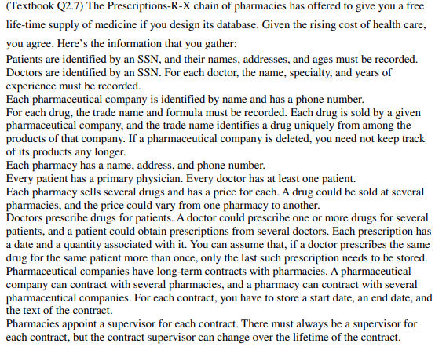

SCENARIO 1

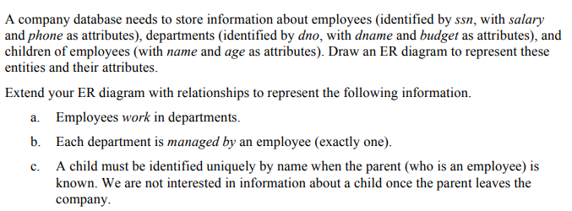

SCENARIO 2

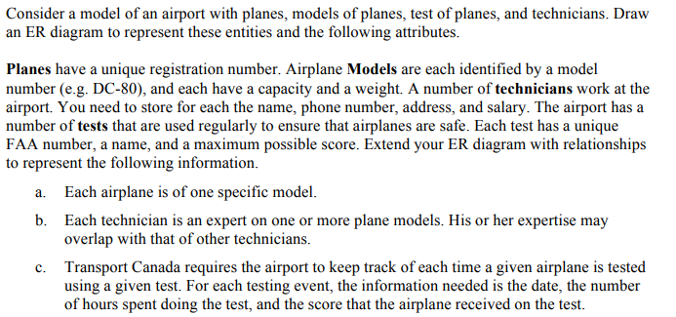

SCENARIO 3

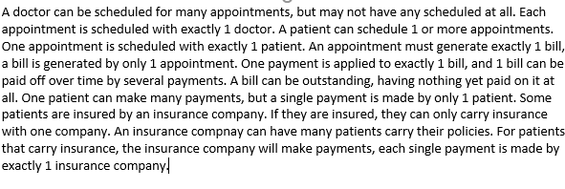

SCENARIO 4

1. TRANSLATE THE ER MODEL INTO A RELATIONAL MODEL AND ATTACH THE COMPLETE DB SCHEMA BELOW. MAKE SURE YOU USE APPROPRIATE CONSTRAINTS TO ENFORCE ALL BUSINESS RULES.
2. MODEL A CONTEXT DIAGRAM/ZERO LEVEL DFD FOR THE FOLLOWING SCENARIO:

*Buses come to a garage for repairs. A mechanic and helper perform the repair, record the reason for the repair and record the total cost of all parts used on a Shop Repair Order.*

*Information on labor, parts and repair outcome is used for billing by the Accounting Department, parts monitoring by the inventory management computer system and a performance review by the supervisor.*

1. IMPLEMENT ALL EXAMPLES IN MANUAL FOR LAB – 10 AND NOTE ANY OBSERVATIONS.